**Step 9: Customizing the Marketing Mix**

In today's competitive business landscape, companies must adapt their marketing strategies to meet the unique needs and preferences of their target segments. This report aims to explore the implications of marketing mix decisions and provide insights into customizing the marketing mix for maximum effectiveness. By studying the profile and detailed description of the target segment, we can determine how product-related aspects should be designed or modified to best cater to their specific requirements. Additionally, reviewing the marketing mix as a whole enables us to align our strategies with the target segment's preferences.

Implications of Marketing Mix Decisions:

The marketing mix consists of the 4 P’s: product, price, place, and promotion. Each element plays a crucial role in influencing customer behavior and satisfaction. When customizing the marketing mix, it is essential to consider the following implications:

1. Product: Analyze the target segment's needs, preferences, and pain points. Identify areas where the existing product can be modified or new products can be developed to address these specific requirements. Customization might involve features, packaging, branding, or even the creation of entirely new product lines.
2. Price: Evaluate the target segment's price sensitivity and purchasing power. Determine the optimal pricing strategy, which may involve competitive pricing, value-based pricing, or premium pricing. It is crucial to strike a balance between affordability for the target segment and profitability for the company.
3. Place: Understand the target segment's preferred distribution channels and buying habits. Ensure the product is available where and when the segment is most likely to make a purchase. This may involve exploring different retail channels, e-commerce platforms or even establishing partnerships with relevant businesses.
4. Promotion: Develop a tailored communication strategy to effectively reach the target segment. Identify the most appropriate marketing channels such as social media, influencer partnerships or traditional advertising, based on the segment's media consumption habits. Craft messages that resonate with their values, interests, and aspirations.

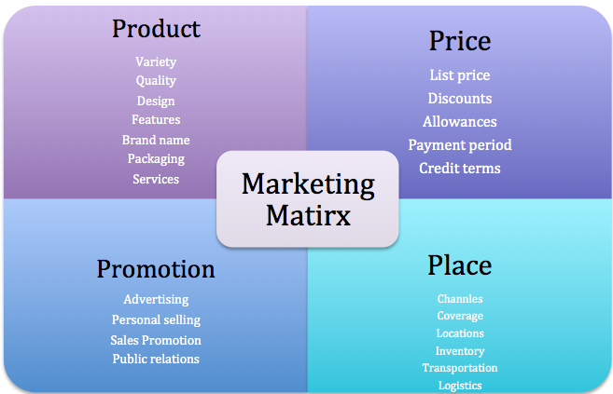

Fig 1. 4 P’s of Marketing Matrix

Profile and Detailed Description of the Target Segment:

To customize the marketing mix successfully, a comprehensive understanding of the target segment is essential. Conduct market research, surveys, and customer interviews to gather demographic, psychographic, and behavioral data. Analyze the information to identify common characteristics, motivations, and pain points within the target segment. This data-driven approach will help create a detailed profile that forms the foundation for customization.

Product-Related Aspects for Target Segment:

Based on the target segment's profile, determine how the product-related aspects should be designed or modified. Consider the following:

1. Features: Adapt the product features to align with the target segment's needs and preferences. Identify unique selling points that differentiate the product from competitors and cater to the segment's specific requirements.
2. Packaging: Design packaging that appeals to the target segment visually and communicates the product's value proposition effectively. Consider factors such as convenience, eco-friendliness, and brand image in packaging decisions.
3. Branding: Develop a brand identity that resonates with the target segment's values and aspirations. Craft compelling brand messaging that communicates the product's benefits and connects emotionally with the segment.

Price-Related Aspects for Target Segment:

When customizing the marketing mix, it is crucial to consider price-related aspects that align with the target segment's preferences and purchasing power. Here are some key considerations:

1. Pricing Strategy: Determine the most appropriate pricing strategy based on the target segment's price sensitivity and willingness to pay:

a. Competitive Pricing: Set prices in line with or slightly below competitors to attract price-conscious customers within the segment.

b. Value-Based Pricing: Emphasize the unique value proposition of the product and set prices accordingly. This strategy works well if the target segment perceives the product as offering superior benefits or solving specific pain points.

c. Premium Pricing: Position the product as a high-end or luxury option, charging a premium price to cater to a segment that values exclusivity or premium features.

1. Discounts and Promotions: Evaluate whether offering discounts, promotions, or bundle deals aligns with the target segment's preferences. This can be particularly effective for price-sensitive segments or during specific periods (e.g. seasonal sales).
2. Payment Options: Consider providing flexible payment options that accommodate the target segment's financial preferences. This may include installment plans, subscription models, or alternative payment methods (e.g. mobile wallets).

Promotion-Related Aspects for Target Segment:

Promotion plays a vital role in reaching and engaging the target segment. To customize the marketing mix effectively, consider the following promotion-related aspects:

1. Communication Channels: Identify the most relevant communication channels to reach the target segment. This may include social media platforms, industry-specific publications, online forums, or offline channels such as events or print media.
2. Messaging and Content: Craft promotional messages and content that resonate with the target segment's values, interests, and aspirations. Use language, imagery, and storytelling techniques that speak directly to their needs and desires. Personalization and customization can enhance the effectiveness of promotional efforts.
3. Influencer Partnerships: Collaborate with influencers or thought leaders who have influence and credibility within the target segment. Their endorsement or promotion of the product can significantly impact the segment's perception and purchasing decisions.
4. Targeted Advertising: Utilize targeted advertising strategies, such as demographic and interest-based targeting, to reach the specific individuals within the target segment.
5. Word-of-Mouth Marketing: Encourage positive word-of-mouth by providing exceptional customer experiences, incentivizing referrals, or implementing loyalty programs.
6. Event Marketing: Consider organizing or participating in events that are relevant to the target segment's interests or industry. This provides an opportunity to engage directly with potential customers, showcase the product, and build brand awareness.

Place-Related Aspects for Target Segment:

Place-related aspects are crucial when customizing the marketing mix to cater to the target segment's preferences and buying habits. Here are key considerations for place-related aspects:

1. Distribution Channels: Identify the most appropriate distribution channels that align with the target segment's shopping behavior and preferences.
2. Geographic Reach: Determine the geographical locations where the target segment is concentrated or where there is a high demand for the product.
3. Retail Partnerships: Establish partnerships with retailers or businesses that have a strong presence among the target segment.
4. Online Presence and User Experience: Invest in an optimized online presence, including user-friendly websites, mobile applications, or dedicated online stores.
5. Supply Chain Management: Optimize the supply chain to ensure timely and efficient delivery of the product to the target segment.
6. After-Sales Support: Consider the target segment's need for after-sales support or customer service.

Reviewing the Marketing Mix in its Entirety:

After customizing the product-related aspects, it is essential to review the entire marketing mix to ensure consistency and alignment. Consider the interplay between product, price, place, and promotion and evaluate:

1. Coherence: Verify that all elements of the marketing mix align with each other and reinforce the desired brand image and positioning for the target segment.
2. Integration: Ensure that the chosen marketing channels, messaging, and pricing strategy work together seamlessly to create a cohesive customer experience.
3. Measurement: Establish key performance indicators (KPIs) to track the effectiveness of the marketing mix in reaching and engaging the target segment. Regularly monitor and analyze data to make informed adjustments as needed.

Conclusion:

Customizing the marketing mix is a vital step in reaching and engaging target segments effectively. By understanding the implications of marketing mix decisions, studying the target segment profile and modifying product-related aspects, companies can create tailored strategies that resonate with their customers. Additionally, reviewing the marketing mix as a whole ensures coherence, integration and measurable success. Due to these efforts, companies can achieve a competitive edge by providing superior value and satisfaction to their target segment.